Week 15 – Python
# Arithmetic Operators
total_marks = 50
obtained_marks = 38
percentage = (obtained_marks / total_marks) * 100
print(percentage)

------------------------------------------------------------------------------------------------------------------------------------------
#Output & String Formatting
name = "Ali"
score = 76
print(name, "scored", score, "%")

------------------------------------------------------------------------------------------------------------------------------------------
#User Input
user_name = input("Enter your name: ")
print("Hello", user_name)

------------------------------------------------------------------------------------------------------------------------------------------
# Numbers
num1 = 9
num2 = 7
result = num1 + num2
print("Sum is:", result)

------------------------------------------------------------------------------------------------------------------------------------------

# Input + Numbers
num1 = input("Enter the first number: ")
num2 = input("Enter the second number: ")
result = int(num1) + int(num2)
print("The result is:", result)

------------------------------------------------------------------------------------------------------------------------------------------
#comparison operators
a = 10
b = 20
print(a > b)
print(a < b)
print(a == b)
print(a != b)

------------------------------------------------------------------------------------------------------------------------------------------
#if - else statements
marks = 55
if marks >= 50:
print("Pass")
else:
print("Fail")

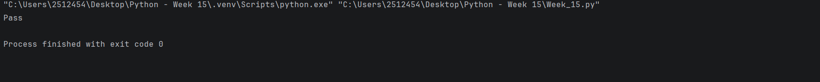
------------------------------------------------------------------------------------------------------------------------------------------
# Arrays
students = ["umais", "hasnain", "rohaan", "raheem"]
print(students[2])
students.append("Bilal")
print(students)

------------------------------------------------------------------------------------------------------------------------------------------
students = ["umais", "hasnain", "rohaan", "raheem"]
students.remove(students[1])
print(students)

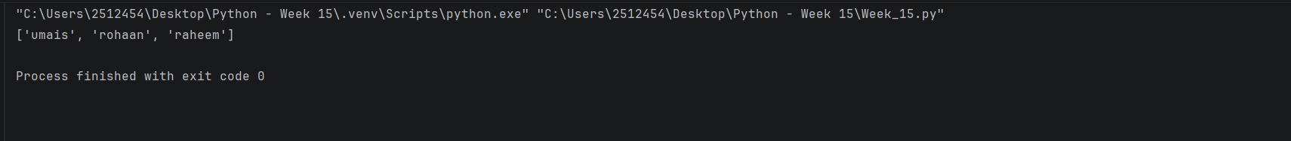
------------------------------------------------------------------------------------------------------------------------------------------
#Loops
for i in range(5):
print("hello")

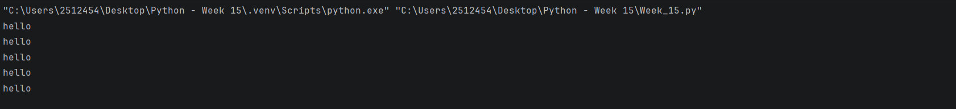
------------------------------------------------------------------------------------------------------------------------------------------
students = ["umais", "hasnain", "rohaan", "raheem"]
for i in students:
print(i)

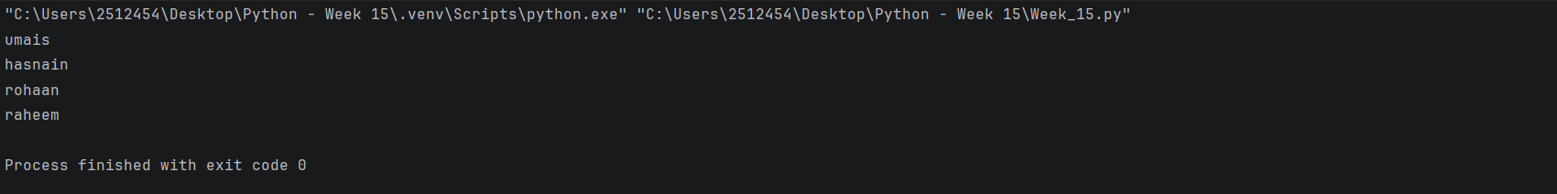
------------------------------------------------------------------------------------------------------------------------------------------
# while loop
count = 1
number = int(input("Enter a number: "))
while count <= 5:
print(count)
count += 1

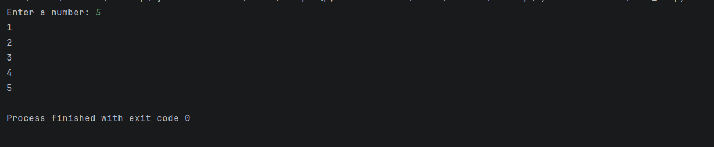
------------------------------------------------------------------------------------------------------------------------------------------
Infinite inputs:
number = int(input("Enter a number: "))
while number != 0:
print("You entered", number)
number = int(input("Enter a number: "))

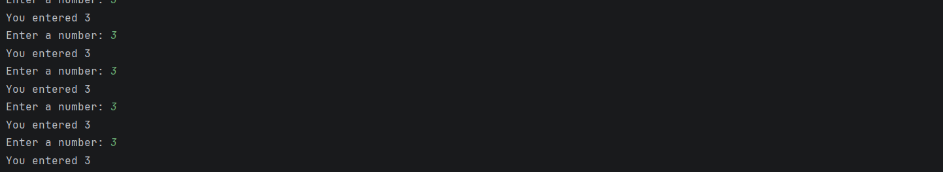
-----------------------------------------------------------------------------------------------------------------------------------------
# nested loops
for i in range(1,5):
for j in range(1,i + 1):
print(j,end=" ")
print()

